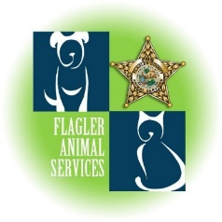
Flagler Animal Services
1 Shelter Drive, Palm Coast, FL 32137
386-246-8612

TRAPPING INSTRUCTIONS
Rules and regulations that officers and the renter of a trap must abide by when trapping.

- Traps are only set in the evening hours. This is to avoid the hottest parts of the day. Special circumstances may result in needing to trap during daytime hours and specific precautions will be taken. Only Officers will be allowed to trap during daytime hours.

- Traps are to be set and baited with cat/dog food approved by Flagler Animal Services. No other food can be used in the traps without prior permission. Traps are not to be tampered with by anyone except an Officer or the renter of the trap. Traps will be covered with a towel to protect the animal from the elements.

- Animal caught in the trap(s) are property of Flagler Humane Society/Flagler Animal Services and are not to be released for any reason. If an owned animal gets into the trap, Flagler Animal Services must be notified, and the animal will remain in the trap until the officer responds.

- Any wildlife that is trapped will be released at the same location where it was caught. Sick or injured wildlife will be removed by Flagler Animal Services and brought to the Flagler Humane Society for evaluation/euthanasia.

- Traps will only be set on the property of the person who requested the trap or the renter of the trap. Traps will not be set on vacant lots without the landowner’s permission.

- Flagler Animal Services will have access to the location of the trap at all times.

- The person requesting or renting the trap is responsible for the theft or destruction of the trap.

Rev. 8.22

